INDIA ELECTION RESULT ANALYSIS IN 2024

1. **Total seats**

select

distinct count(const_id)

from constituencywise_results;

**Output:**

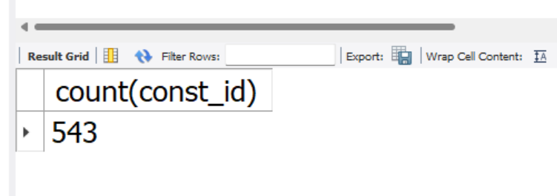

1. **Total seats available for election in each state:**

select

count(parliament_constituency) as total_seats,

s.state as state_name

from statewise_results sr

join states s on sr.state_id = s.state_id

group by s.state;

**Output:**

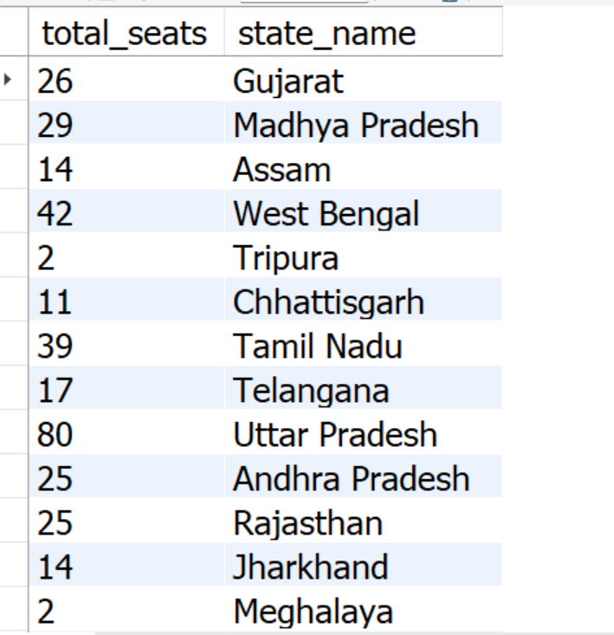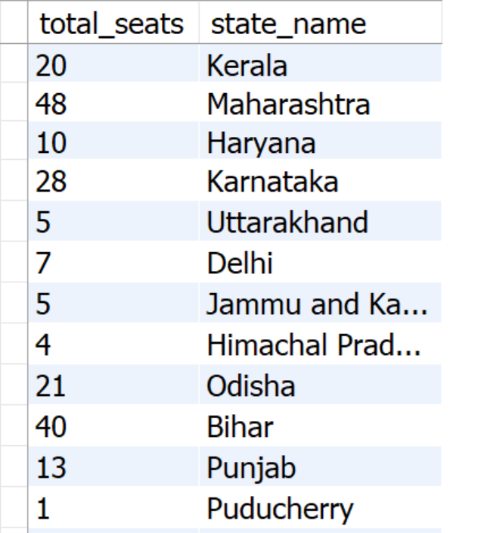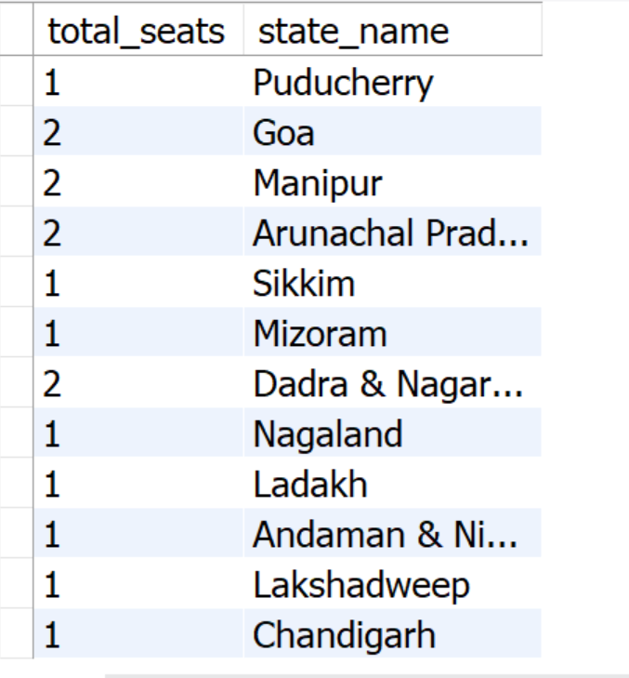

**3.Total seats won by NDA alliance:**

select

sum(case

when party in (

'Bharatiya Janata Party - BJP',

'Telugu Desam - TDP',

'Janata Dal (United) - JD(U)',

'Shiv Sena - SHS',

'AJSU Party - AJSUP',

'Apna Dal (Soneylal) - ADAL',

'Asom Gana Parishad - AGP',

'Hindustani Awam Morcha (Secular) - HAMS',

'Janasena Party - JnP',

'Janata Dal (Secular) - JD(S)',

'Lok Janshakti Party(Ram Vilas) - LJPRV',

'Nationalist Congress Party - NCP',

'Rashtriya Lok Dal - RLD',

'Sikkim Krantikari Morcha - SKM'

) then won

else 0

end) as NDA_total_seats_won

from partywise_results;

Output:

1. Seats won by NDA alliance parties:

select

party as party_name,

won as seats_won

from partywise_results

where party in(

'Bharatiya Janata Party - BJP',

'Telugu Desam - TDP',

'Janata Dal (United) - JD(U)',

'Shiv Sena - SHS',

'AJSU Party - AJSUP',

'Apna Dal (Soneylal) - ADAL',

'Asom Gana Parishad - AGP',

'Hindustani Awam Morcha (Secular) - HAMS',

'Janasena Party - JnP',

'Janata Dal (Secular) - JD(S)',

'Lok Janshakti Party(Ram Vilas) - LJPRV',

'Nationalist Congress Party - NCP',

'Rashtriya Lok Dal - RLD',

'Sikkim Krantikari Morcha - SKM')

order by seats_won desc;

Output:

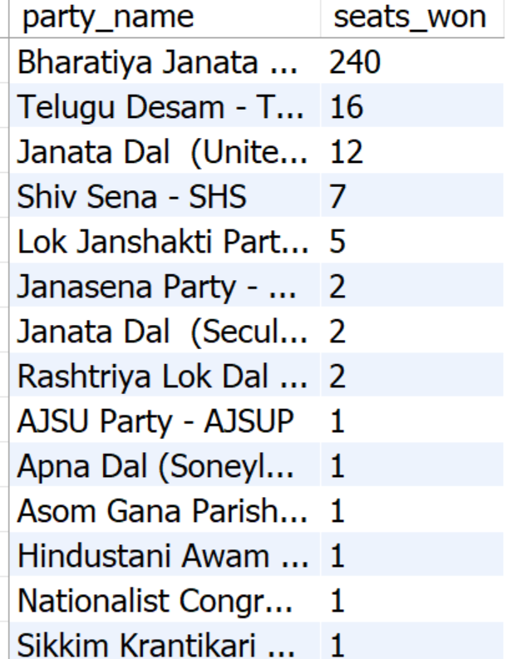

1. Total seats won by INDIA allaiance:

select

sum(case

when party in(

'Indian National Congress - INC',

'Aam Aadmi Party - AAAP',

'All India Trinamool Congress - AITC',

'Bharat Adivasi Party - BHRTADVSIP',

'Communist Party of India (Marxist) - CPI(M)',

'Communist Party of India (Marxist-Leninist) (Liberation) - CPI(ML)(L)',

'Communist Party of India - CPI',

'Dravida Munnetra Kazhagam - DMK',

'Indian Union Muslim League - IUML',

'Nat`Jammu & Kashmir National Conference - JKN',

'Jharkhand Mukti Morcha - JMM',

'Jammu & Kashmir National Conference - JKN',

'Kerala Congress - KEC',

'Marumalarchi Dravida Munnetra Kazhagam - MDMK',

'Nationalist Congress Party Sharadchandra Pawar - NCPSP',

'Rashtriya Janata Dal - RJD',

'Rashtriya Loktantrik Party - RLTP',

'Revolutionary Socialist Party - RSP',

'Samajwadi Party - SP',

'Shiv Sena (Uddhav Balasaheb Thackrey) - SHSUBT',

'Viduthalai Chiruthaigal Katchi - VCK'

) then won

else 0

end) as total_seats_won_india

from partywise_results;

Output:

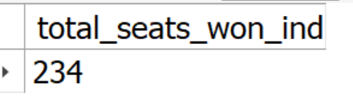

1. **Seats won by parties in INDIA alliance:**

select

party as party_name,

won as seats_won

from partywise_results

where party in (

'Indian National Congress - INC',

'Aam Aadmi Party - AAAP',

'All India Trinamool Congress - AITC',

'Bharat Adivasi Party - BHRTADVSIP',

'Communist Party of India (Marxist) - CPI(M)',

'Communist Party of India (Marxist-Leninist) (Liberation) - CPI(ML)(L)',

'Communist Party of India - CPI',

'Dravida Munnetra Kazhagam - DMK',

'Indian Union Muslim League - IUML',

'Nat`Jammu & Kashmir National Conference - JKN',

'Jharkhand Mukti Morcha - JMM',

'Jammu & Kashmir National Conference - JKN',

'Kerala Congress - KEC',

'Marumalarchi Dravida Munnetra Kazhagam - MDMK',

'Nationalist Congress Party Sharadchandra Pawar - NCPSP',

'Rashtriya Janata Dal - RJD',

'Rashtriya Loktantrik Party - RLTP',

'Revolutionary Socialist Party - RSP',

'Samajwadi Party - SP',

'Shiv Sena (Uddhav Balasaheb Thackrey) - SHSUBT',

'Viduthalai Chiruthaigal Katchi - VCK')

order by seats_won desc;

**Output:**

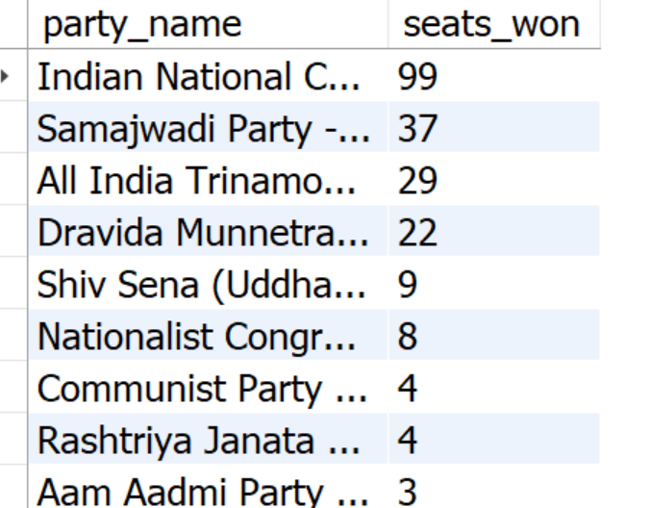

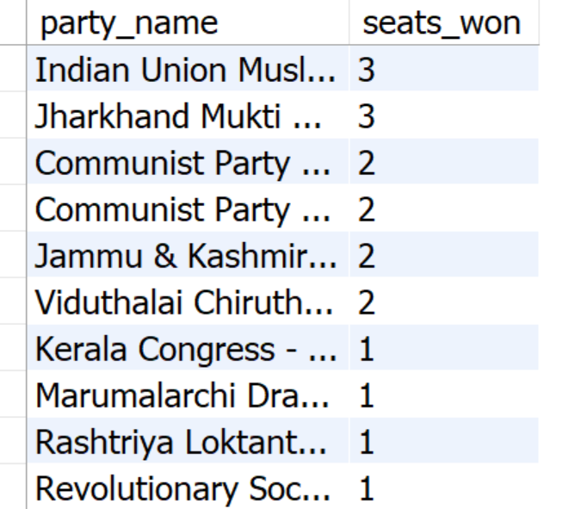

1. **-- Add new column field in table partywise_results to get the Party Allianz as NDA, I.N.D.I.A and OTHER**

alter table partywise_results

add party_alliance varchar(50);

update partywise_results

set party_alliance = 'I.N.D.I.A'

where party in (

'Indian National Congress - INC',

'Aam Aadmi Party - AAAP',

'All India Trinamool Congress - AITC',

'Bharat Adivasi Party - BHRTADVSIP',

'Communist Party of India (Marxist) - CPI(M)',

'Communist Party of India (Marxist-Leninist) (Liberation) - CPI(ML)(L)',

'Communist Party of India - CPI',

'Dravida Munnetra Kazhagam - DMK',

'Indian Union Muslim League - IUML',

'Jammu & Kashmir National Conference - JKN',

'Jharkhand Mukti Morcha - JMM',

'Kerala Congress - KEC',

'Marumalarchi Dravida Munnetra Kazhagam - MDMK',

'Nationalist Congress Party Sharadchandra Pawar - NCPSP',

'Rashtriya Janata Dal - RJD',

'Rashtriya Loktantrik Party - RLTP',

'Revolutionary Socialist Party - RSP',

'Samajwadi Party - SP',

'Shiv Sena (Uddhav Balasaheb Thackrey) - SHSUBT',

'Viduthalai Chiruthaigal Katchi - VCK'

);

update partywise_results

set party_alliance = 'N.D.A'

where party in(

'Bharatiya Janata Party - BJP',

'Telugu Desam - TDP',

'Janata Dal (United) - JD(U)',

'Shiv Sena - SHS',

'AJSU Party - AJSUP',

'Apna Dal (Soneylal) - ADAL',

'Asom Gana Parishad - AGP',

'Hindustani Awam Morcha (Secular) - HAMS',

'Janasena Party - JnP',

'Janata Dal (Secular) - JD(S)',

'Lok Janshakti Party(Ram Vilas) - LJPRV',

'Nationalist Congress Party - NCP',

'Rashtriya Lok Dal - RLD',

'Sikkim Krantikari Morcha - SKM'

);

update partywise_results

set party_alliance = 'others'

where party_alliance is null;

**Output:**

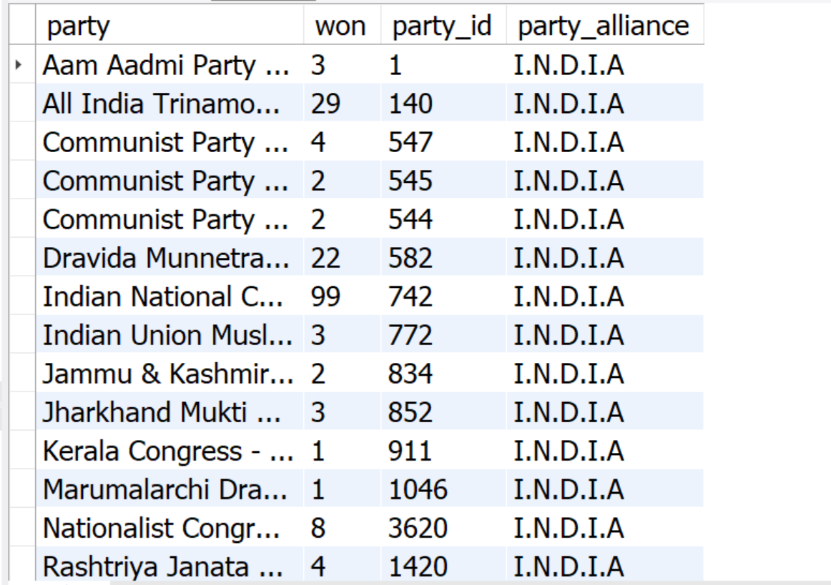

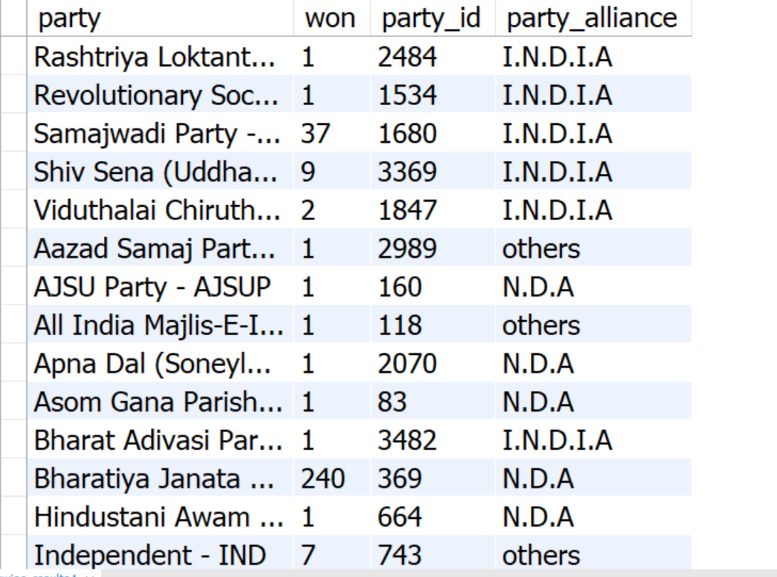

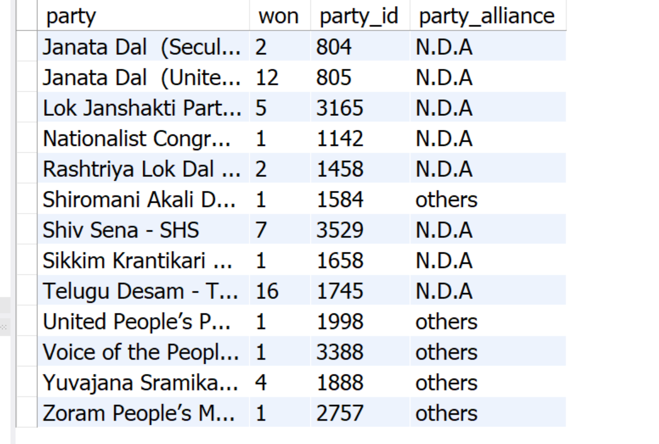

1. **Which party alliance (NDA, I.N.D.I.A, or OTHER) won the most seats across all states?**

select party_alliance, sum(won) as total_won

from partywise_results

group by party_alliance

order by total_won desc

Output:

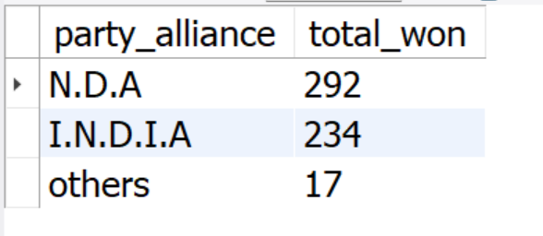

1. **Winning candidate's name, their party name, total votes, and the margin of victory for a specific state and constituency?**

select

cr.winning_candidate,

pr.party as party_name,

cr.constituency_name,

cr.total_votes,

cr.margin,

s.state

from constituencywise_results cr

inner join partywise_results pr on cr.party_id=pr.party_id

inner join statewise_results sr

on cr.parliament_constituency = sr.parliament_constituency

inner join states s on sr.state_id = s.state_id

where s.state='Uttar Pradesh'

and cr.constituency_name ='AGRA';

**Output:**

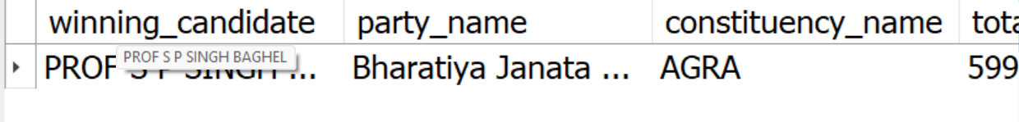

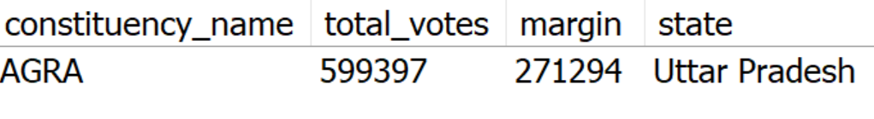

1. **What is the distribution of EVM votes versus postal votes for candidates in a specific constituency?**

select candidate, postal_votes, evm_votes

from constituencywise_details cd

join constituencywise_results cr

on cd.const_id = cr.const_id

where constituency_name ='AGRA';

Output:

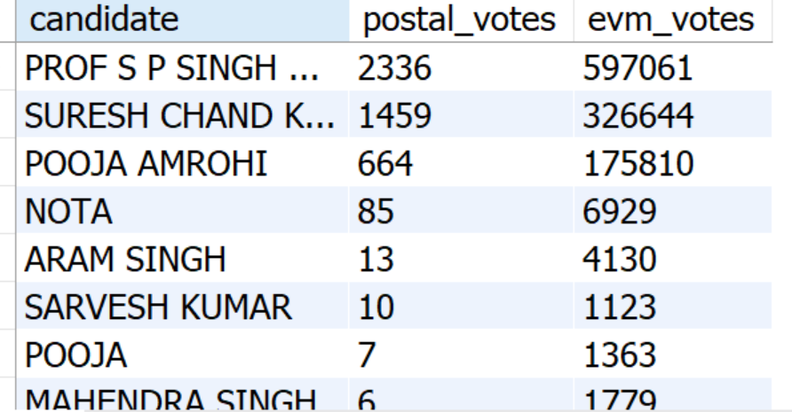

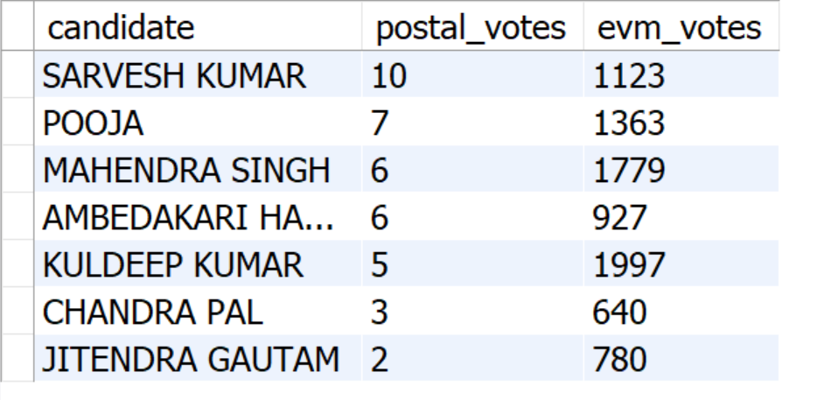

1. **Which parties won the most seats in s State, and how many seats did each party win?**

ELECT

pr.party AS party_name,

s.state,

COUNT(*) AS total_constituencies

FROM statewise_results sr

join states s

on sr.state_id =s.state_id

JOIN constituencywise_results cr

ON sr.parliament_constituency = cr.parliament_constituency

JOIN partywise_results pr

ON cr.party_id = pr.party_id

where s.state ='Tamil Nadu'

group by pr.party

order by total_constituencies desc;

**Output**:

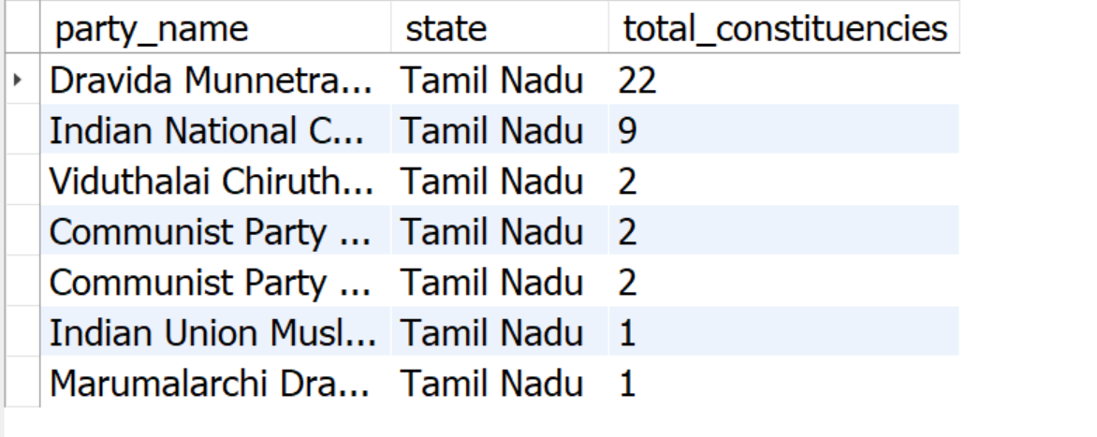

1. **What is the total number of seats won by each party alliance (NDA, I.N.D.I.A, and OTHER) in each state for the India Elections 2024**

select s.state as state_name,

sum(case when p.party_alliance = 'I.N.D.I.A'then 1 else 0 end) as INDIA_seats,

sum(case when p.party_alliance ='N.D.A' then 1 else 0 end) as NDA_seats,

sum(case when p.party_alliance ='others' then 1 else 0 end) as others_seats

from partywise_results p

join constituencywise_results cr on p.party_id = cr.party_id

join statewise_results sr on cr.parliament_constituency = sr.parliament_constituency

join states s on sr.state_id =s.state_id

group by s.state;

**Output**:

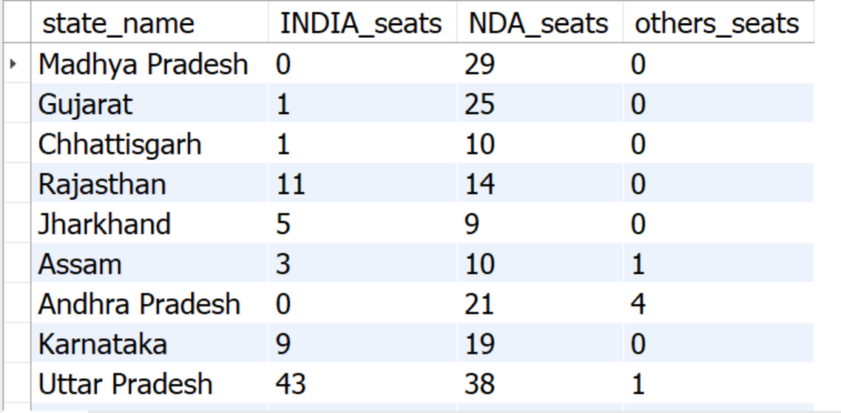

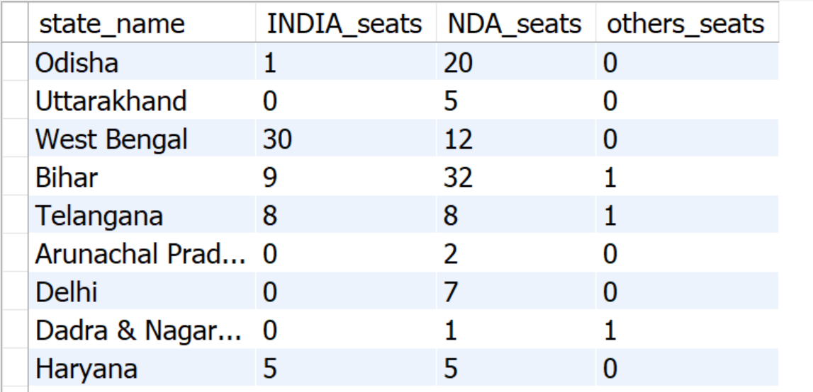

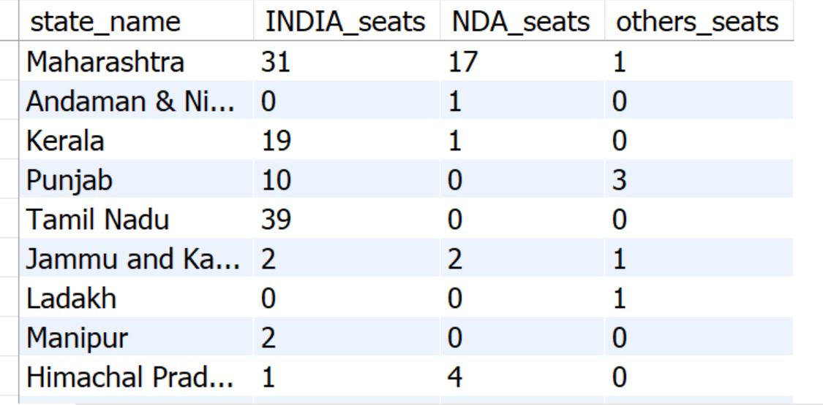

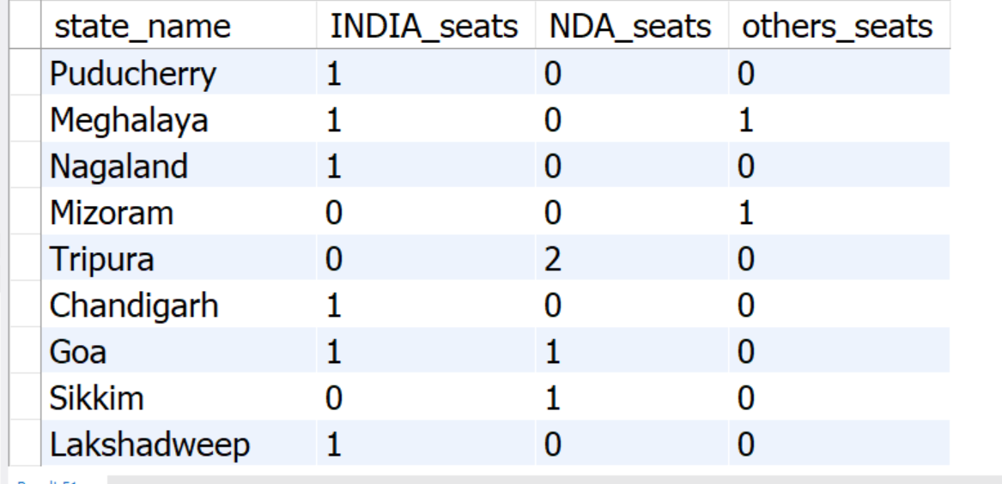

1. **Which candidate received the highest number of EVM votes in each constituency (Top 10)?**

select

cd.candidate,

cd.evm_votes,

cr.constituency_name

from constituencywise_details cd

join constituencywise_results cr

on cd.const_id = cr.const_id

order by evm_votes desc

limit 10;

* + - If the evm_votes of the more than one candidate is same, it may exclude some valid results.
    - Does **not guarantee one winner per constituency** (could show multiple candidates from the same place)

So, the below query works well.

SELECT

cr.constituency_name,

cd.const_id,

cd.candidate,

cd.evm_votes

FROM constituencywise_details cd

JOIN constituencywise_results cr ON cd.const_id = cr.const_id

JOIN (

SELECT const_id, MAX(evm_votes) AS max_votes

FROM constituencywise_details

GROUP BY const_id

) max_votes_tbl

ON cd.const_id = max_votes_tbl.const_id

AND cd.evm_votes = max_votes_tbl.max_votes

ORDER BY cd.evm_votes DESC

LIMIT 10;

**Output**:

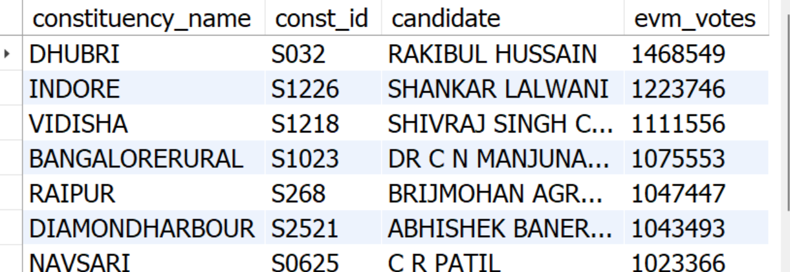 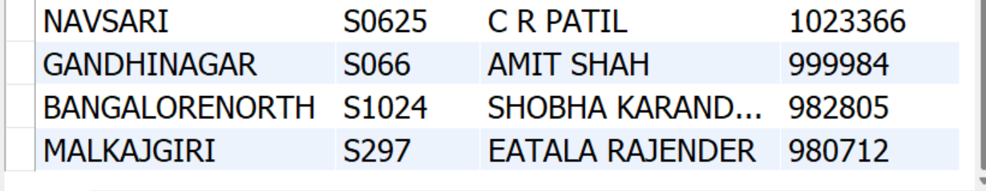

1. **Which candidate won and which candidate was the runner-up in each constituency of State for the 2024 elections?**

WITH RankedCandidates AS (

SELECT

cd.Const_ID,

cd.Candidate,

cd.Party,

cd.EVM_Votes,

cd.Postal_Votes,

cd.EVM_Votes + cd.Postal_Votes AS Total_Votes,

ROW_NUMBER() OVER (PARTITION BY cd.Const_ID ORDER BY cd.EVM_Votes + cd.Postal_Votes DESC) AS VoteRank

FROM

constituencywise_details cd

JOIN

constituencywise_results cr ON cd.Const_ID = cr.Const_ID

JOIN

statewise_results sr ON cr.Parliament_Constituency = sr.Parliament_Constituency

JOIN

states s ON sr.State_ID = s.State_ID

WHERE

s.State = 'Maharashtra'

)

SELECT

cr.Constituency_Name,

MAX(CASE WHEN rc.VoteRank = 1 THEN rc.Candidate END) AS Winning_Candidate,

MAX(CASE WHEN rc.VoteRank = 2 THEN rc.Candidate END) AS Runnerup_Candidate

FROM

RankedCandidates rc

JOIN

constituencywise_results cr ON rc.Const_ID = cr.Const_ID

GROUP BY

cr.Constituency_Name

ORDER BY

cr.Constituency_Name;

**Output**:

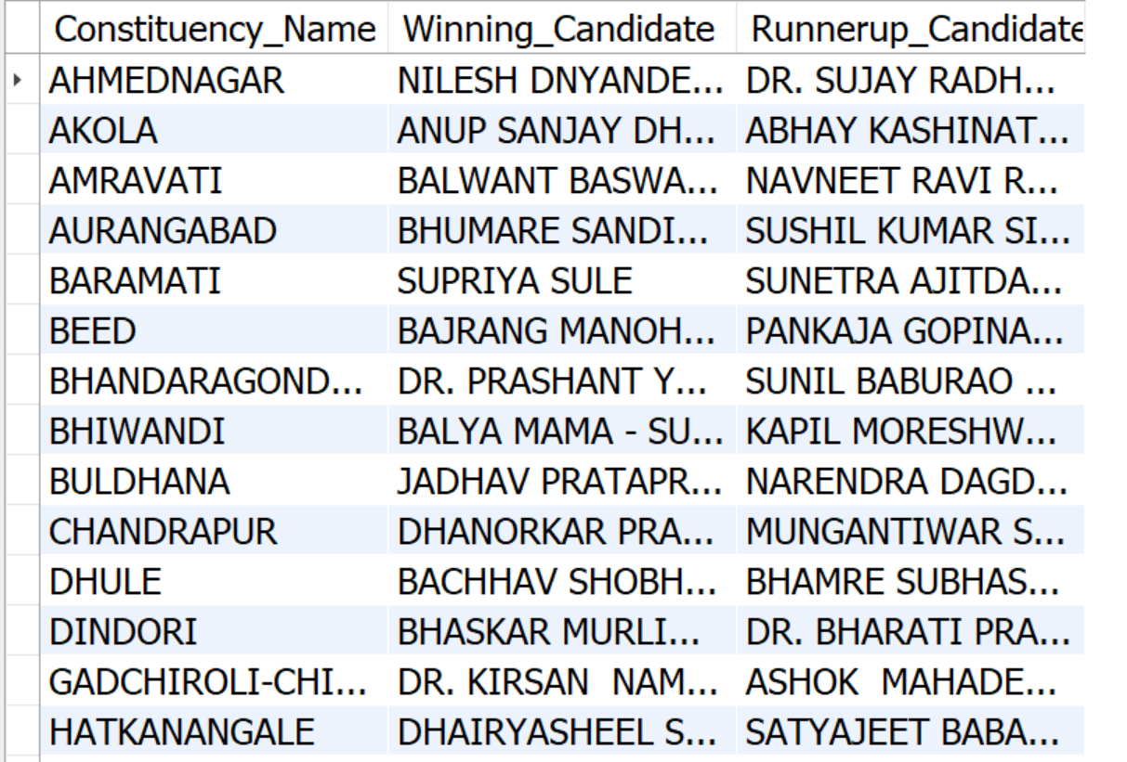

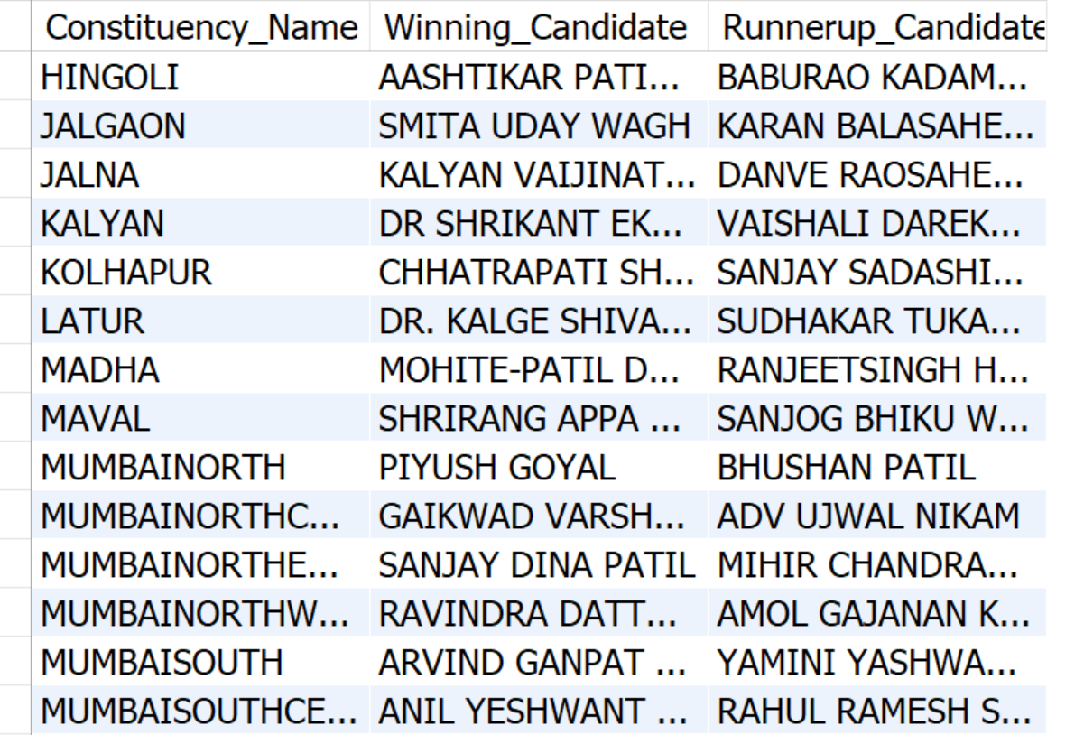

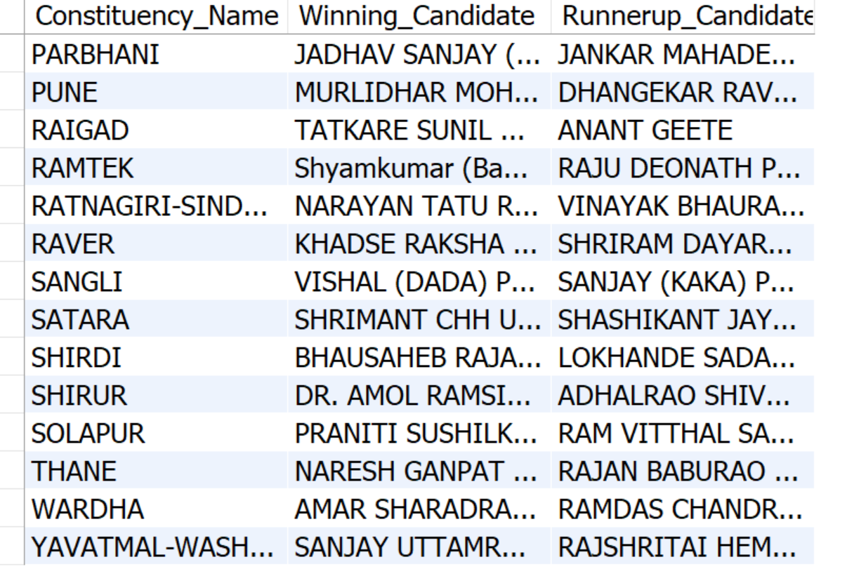

1. **For the state of Maharashtra, what are the total number of seats, total number of candidates, total number of parties, total votes (including EVM and postal), and the breakdown of EVM and postal votes?**

select

count(distinct cr.const_id) as total_seats,

count(distinct cd.candidate) as total_candidates,

count(distinct p.party) as total_parties,

sum(cd.evm_votes + cd.postal_votes) as total_votes,

sum(cd.evm_votes) as total_evm_votes,

sum(cd.postal_votes) as total_postal_votes

from constituencywise_results cr

join constituencywise_details cd on cr.const_id = cd.const_id

join statewise_results sr on cr.parliament_constituency= sr.parliament_constituency

join states s on sr.state_id = s.state_id

join partywise_results p on cr.party_id = p.party_id

where s.state='Maharashtra';

**Output**:

